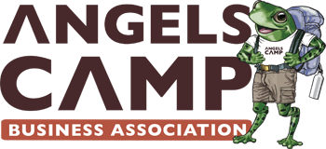
1333
Angels Camp Business Association
P.O. Box 62 Angels Camp, CA. 95222
209.736.1333 admin@angelscampbusiness.com
https://www.angelscampbusinessassociation.com

____________________________________________________________
2026 ANNUAL MEMBERSHIP DUES
ACBA Membership year is from January to December.
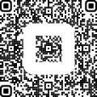
Non-Profit & Friends Membership
+ $2.50 Processing Fee
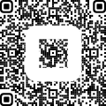
Primary Business Membership
+ $2.50 Processing Fee

Scan It To Pay It!

___________ $160 for Primary Business Membership
___________ $80 for Additional Business –
use a separate membership application
to receive full benefit
___________ $50 Individuals “Friends of ACBA”
___________ $50 Non-Profit Organization

Business/Individuals/NonProfits____________________________________________________
Contact Name ___________________________________________________________________
Mailing Address ______________________________City__________________Zip __________
Physical Address _____________________________City__________________Zip___________
Phone _________________________________ Cell: ____________________________________
E-Mail ___________________________Business Website _______________________________
Enclosed is my check for $_____________ for our 2026 ACBA membership.
Make check payable to ACBA and mail to ACBA at P.O. Box 62, Angels Camp, CA 95222

Please list my business under the following categories:

___ Food: restaurants, food trucks, deli, quick serve, etc. ____ Bar ____ Entertainment Venue
___ Retail: general, gifts, clothing, hardware, jewelry, home goods, appliances, furniture, grocery, etc. ___ Agriculture ___ Automotive: sales, repair, parts, gas, tires, ___ Banking, Finance & Title
___ Professional Service: accounting,, book keeping, taxes, architects, engineers, legal, marketing
___ Home Services: plumbing, electrical, landscaping, house cleaning, roofing, painting, flooring,
___ Real Estate: residential sales commercial sales and leasing, property management ___Pet Care
___ Personal Care Services: hair, nails, massage, facial, etc. ___ Non-Profit, Education or Ministry
___ Health Care: medical, optometry, dental, chiropractic, physical therapy, hospital/clinic
____ Other” _____________________________________________________________________

The following are the current ACBA-sponsored events – let us know if you’d like to help:
__ Christmas Parade __Bow & Bough Making __Host A “Business After Hours” Mixer
__ Ribbon Cuttings __ Farmer’s Market Season __ Jr. Frog Jump __ General Event Help
What events would you like to see in our community_______________________________

ACBA is self-funded via membership fees, events and related sponsorships. We strive to make our business community flourish. Is there anything we can do to help your business ________________________________________________________________________________________________________________________________________________________________
Continue on back side, if needed. We can also call you to discuss your thoughts. Let us know.

